**Dreamweaver theater**

*Developer Guide*

|  |  |  |
| --- | --- | --- |
| **Supervisor.** | **Miss Aatika** | |
| **Batch.** | **2109c1** | |
| **Group.** |  | |
| **Serial No.** | **Enrollment Number** | **Student Name** |
| 1. | Student1332444 | M. Taha Khan |
| 2. | Student1332448 | Fahad Khan |
| 3. | Student1331510 | Hafeez ur Rehman |

1. **Home** (*index (1).html*)

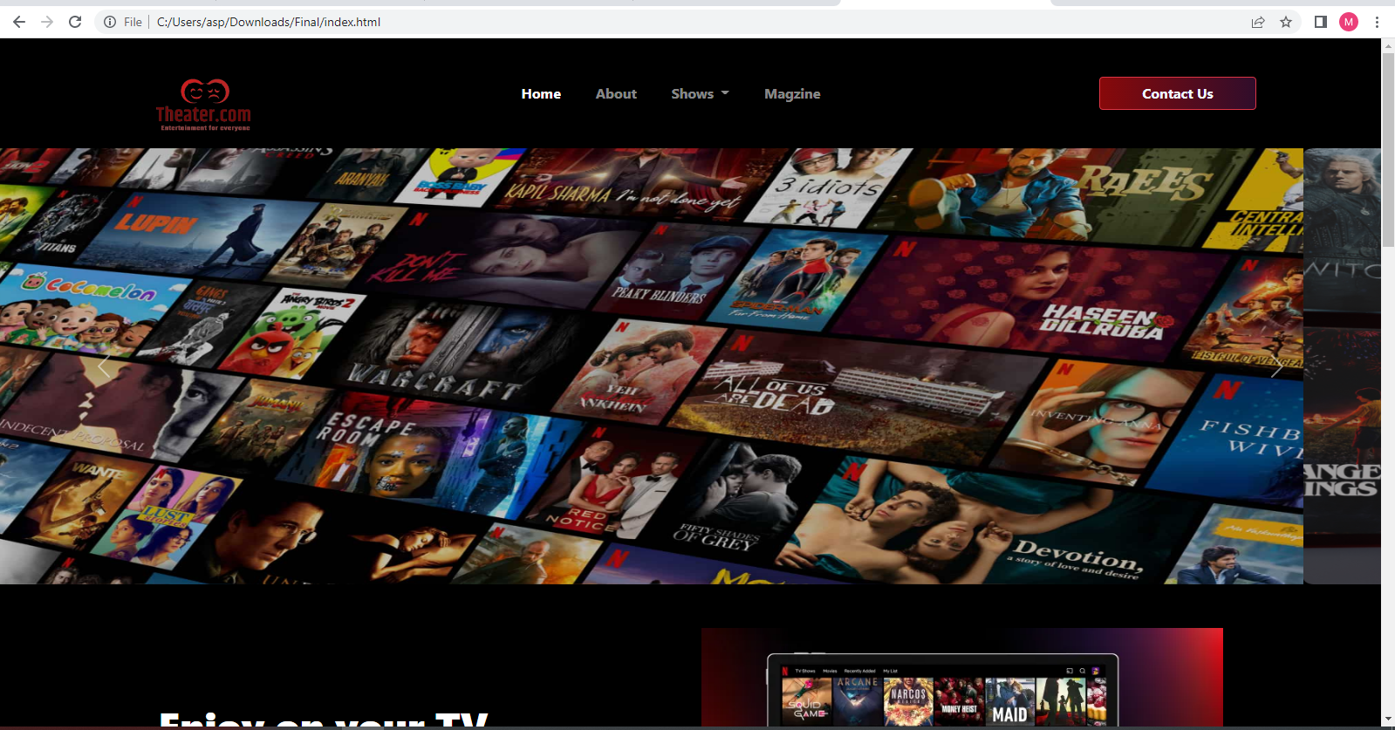

***Figure 1: Home page to Dreamweaver theater***

 Our Slogan has given to the peoples toward our website. “DREAMWAEVER THEATER”.

* By clicking (**contact**) button user while redirect to the contact webpage.

**Code of Home page**

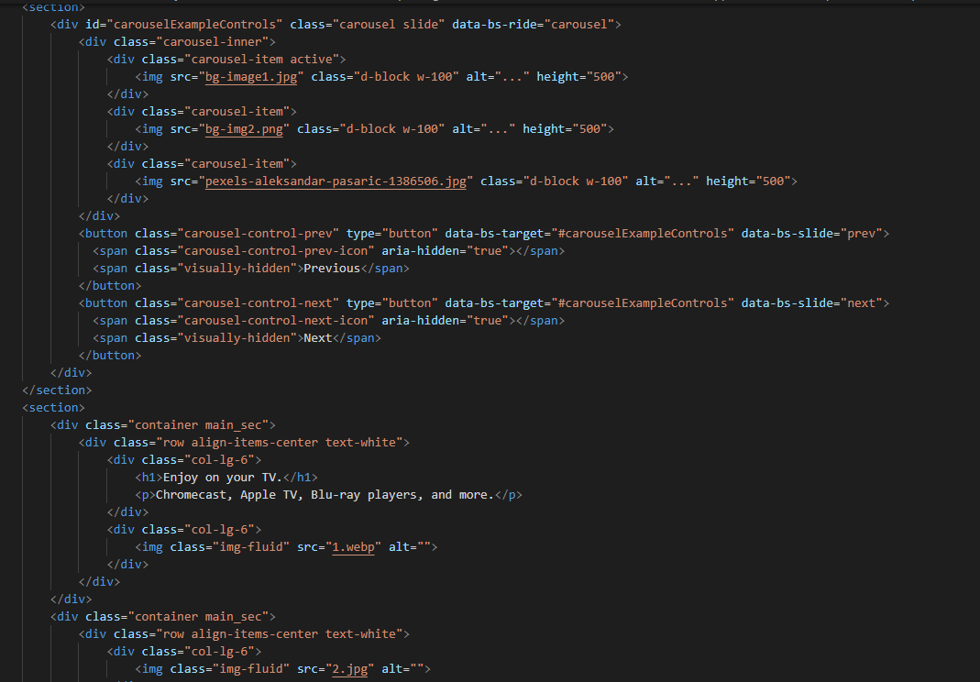

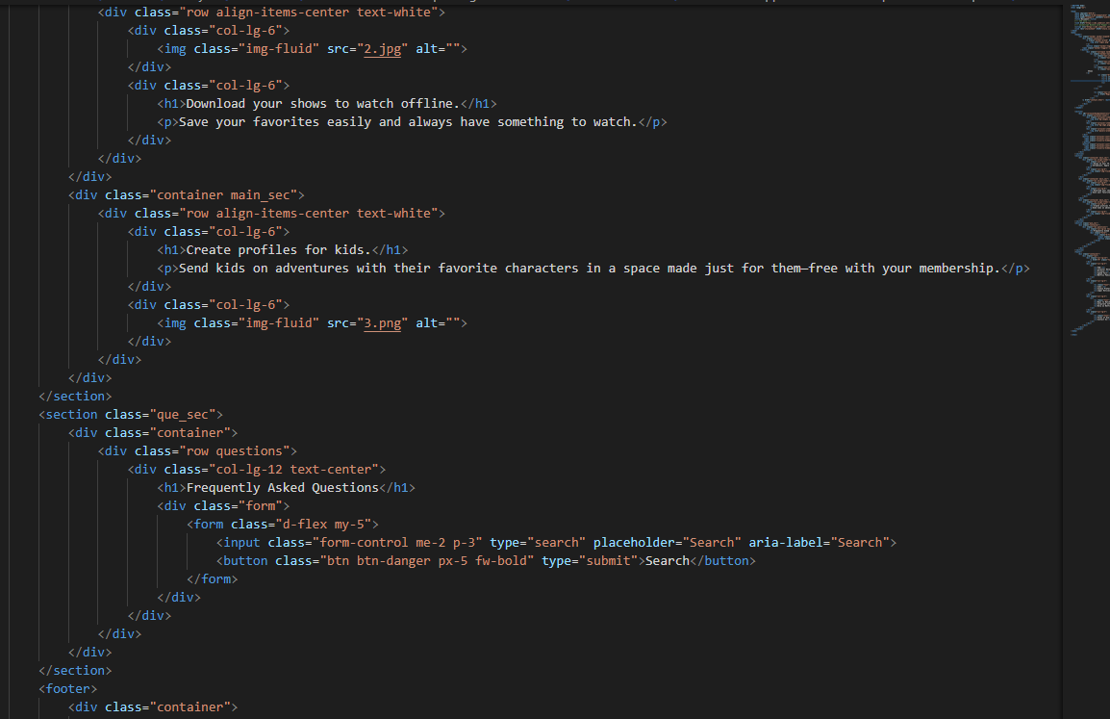

1. **Navbar (index (1).html)**

**

***Figure 2: Navbar***

We have given seven essentials. By clicking any of the essential’s and redirect to the linked page. (0. index (1).html)

**Code of Navbar**

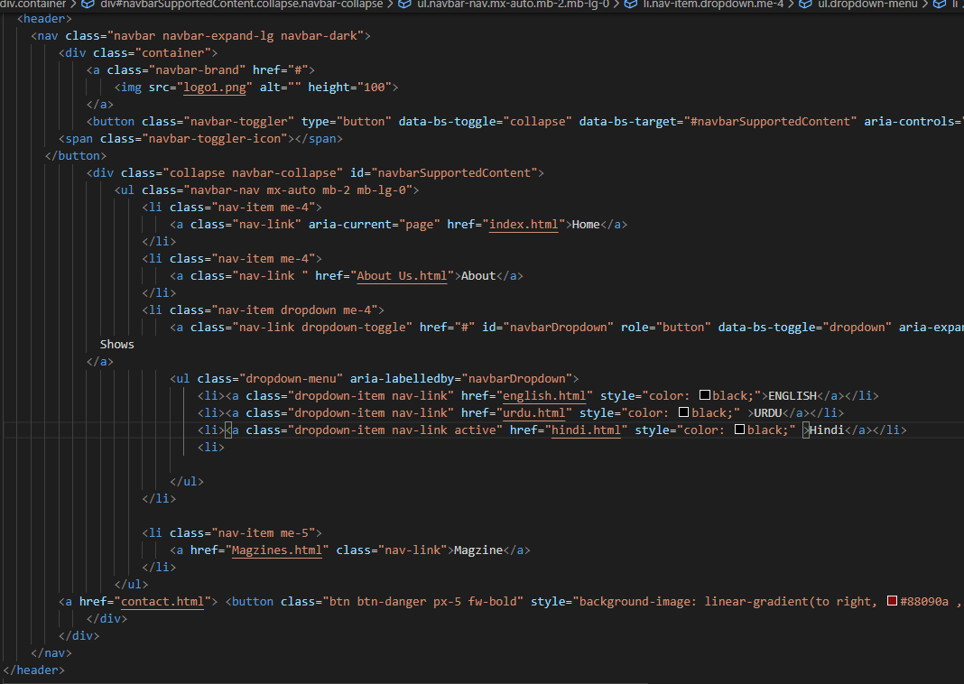

1. **About us (index (1).html)**



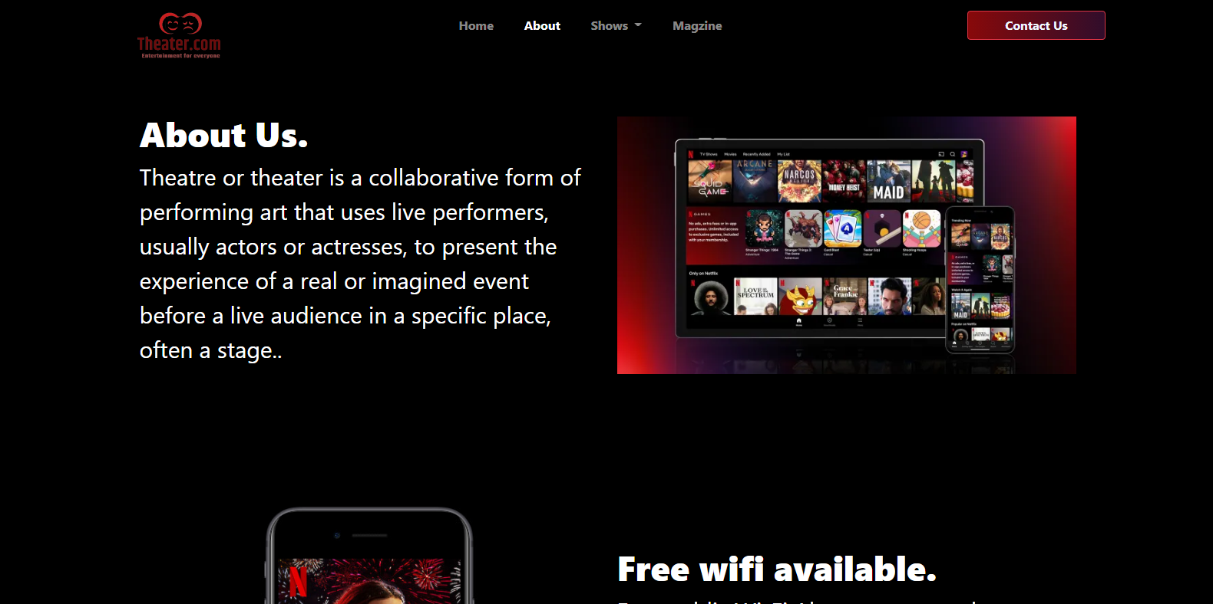

 ***Figure 3: About us***

**

***Wifi services****: We are providing free wifi services to our visitors*

* ***Cleaning Service:*** *We have mentioned that we are providing theater cleaning services to the customer.*

***Code of About Us***

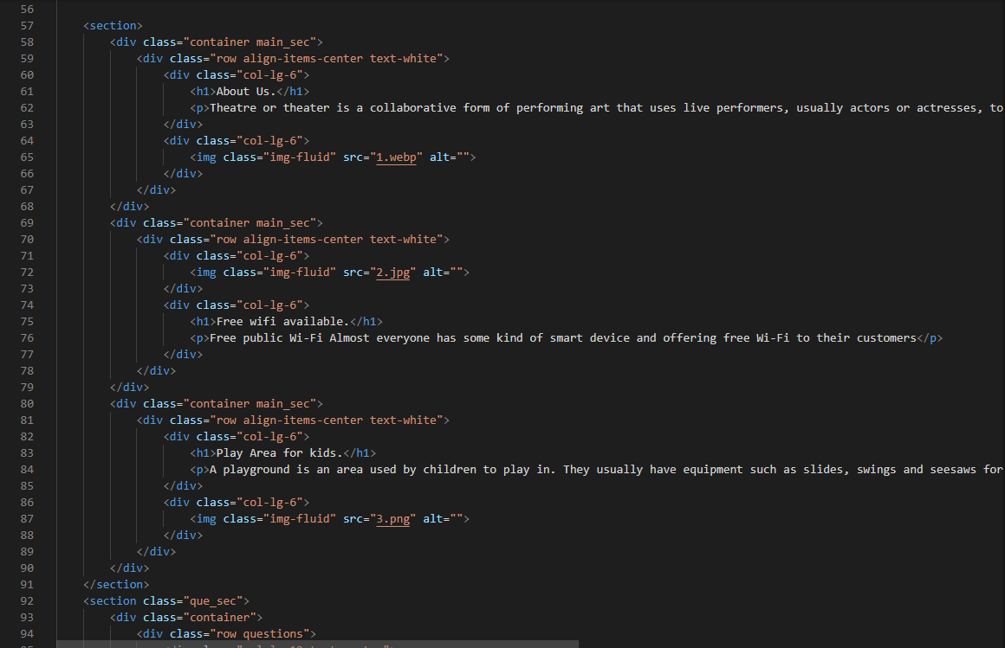

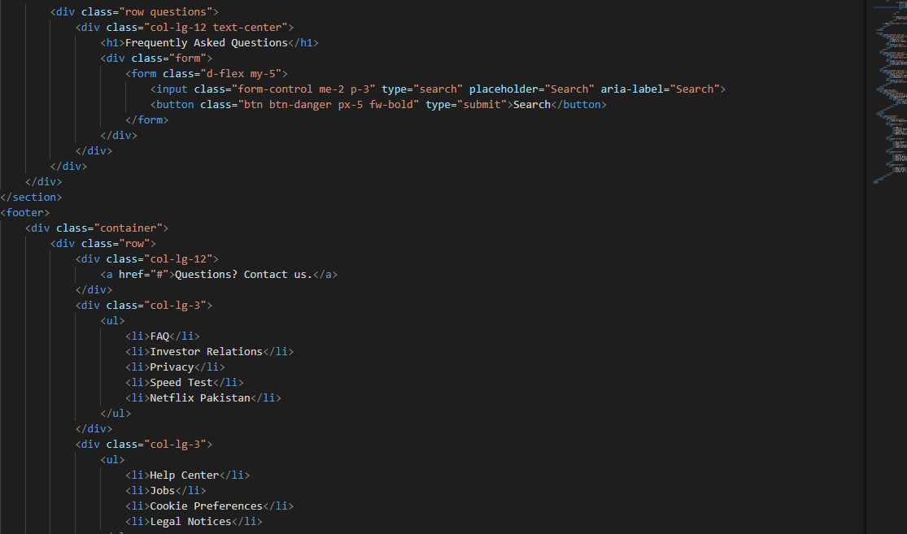

***Magzines (index (1).html)***

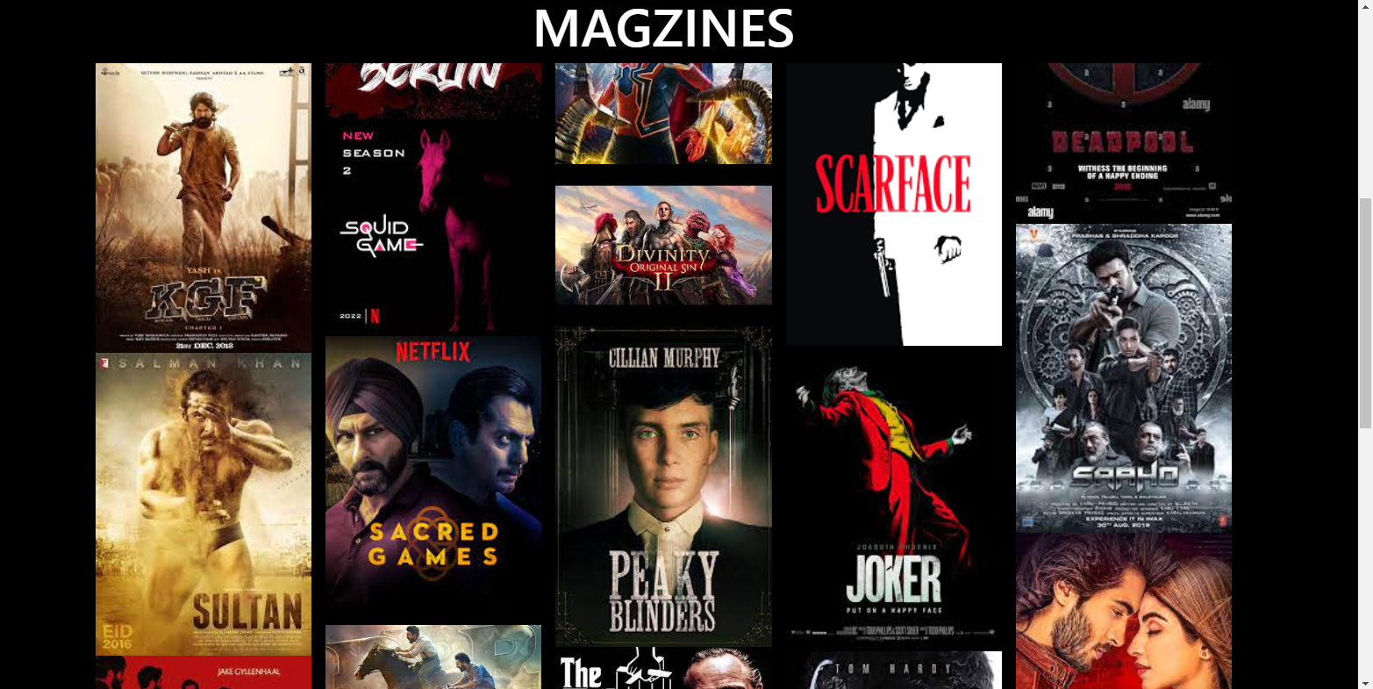



***Figure 5: Magzines***

***Description:*** *Every theater website have webpage about magzines in many different languages for some unique shows.*

***“Description of Magzines”***

*We have given some unique kind of shows in our Magzines page*

*And provide hover to highlight the name and pictures so that people who are visiting our website can gain knowledge.*

***Code of Magzines***

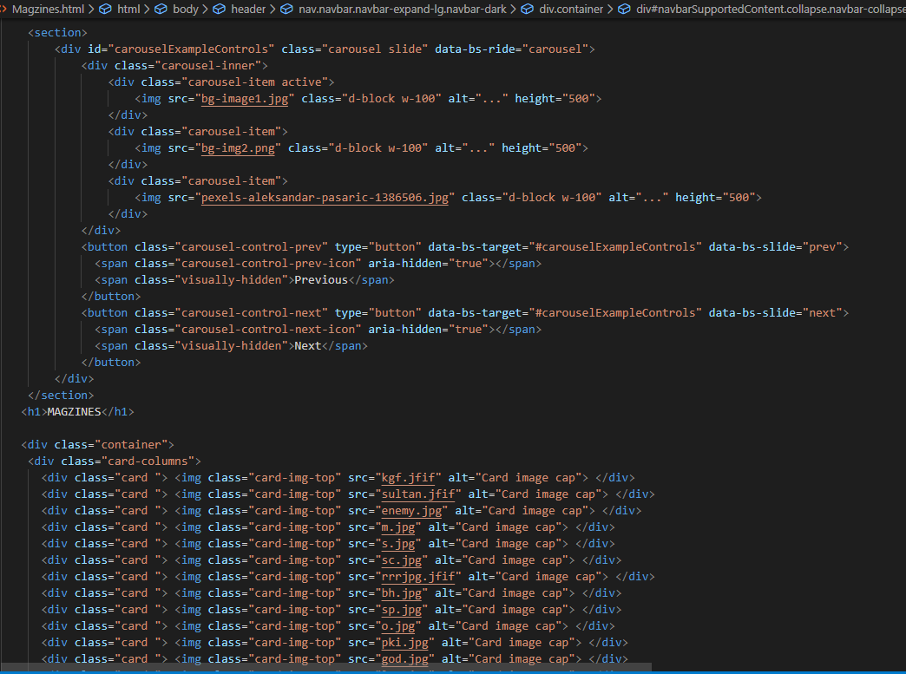

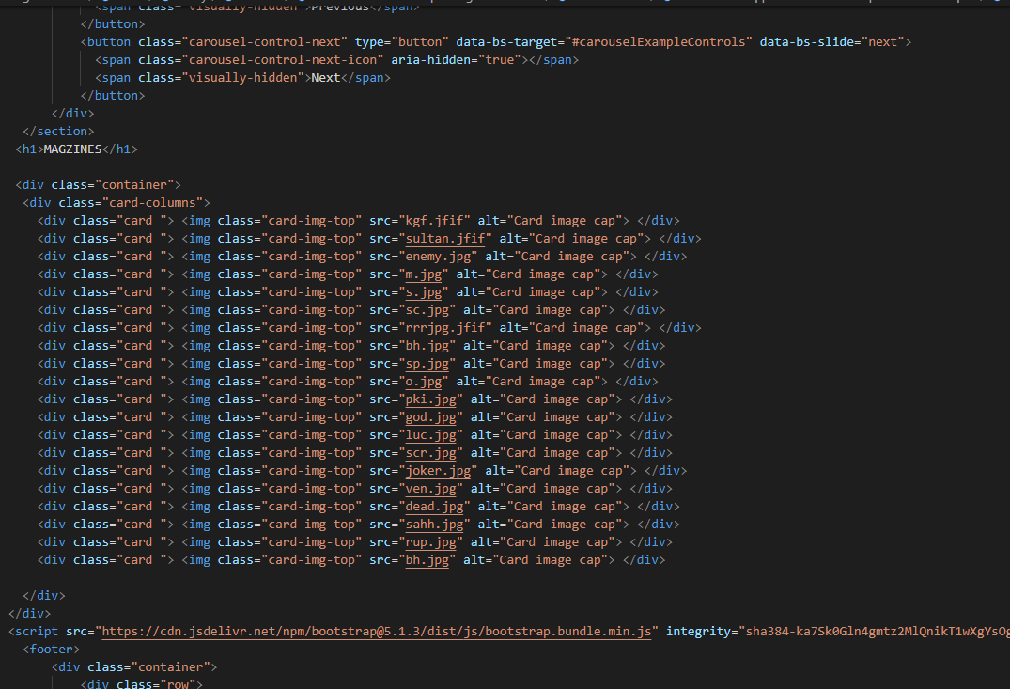

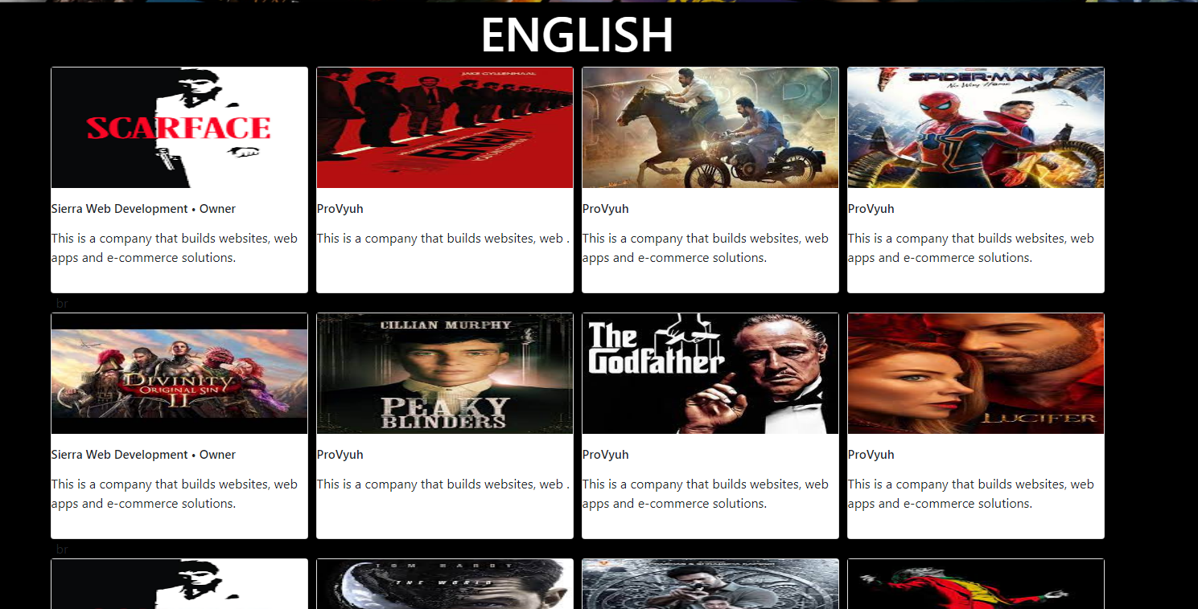

***Code of English shows page***

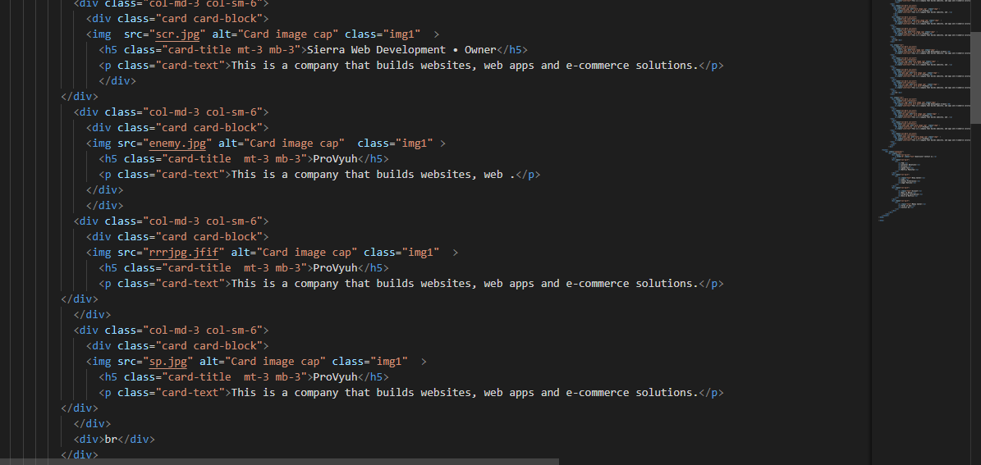

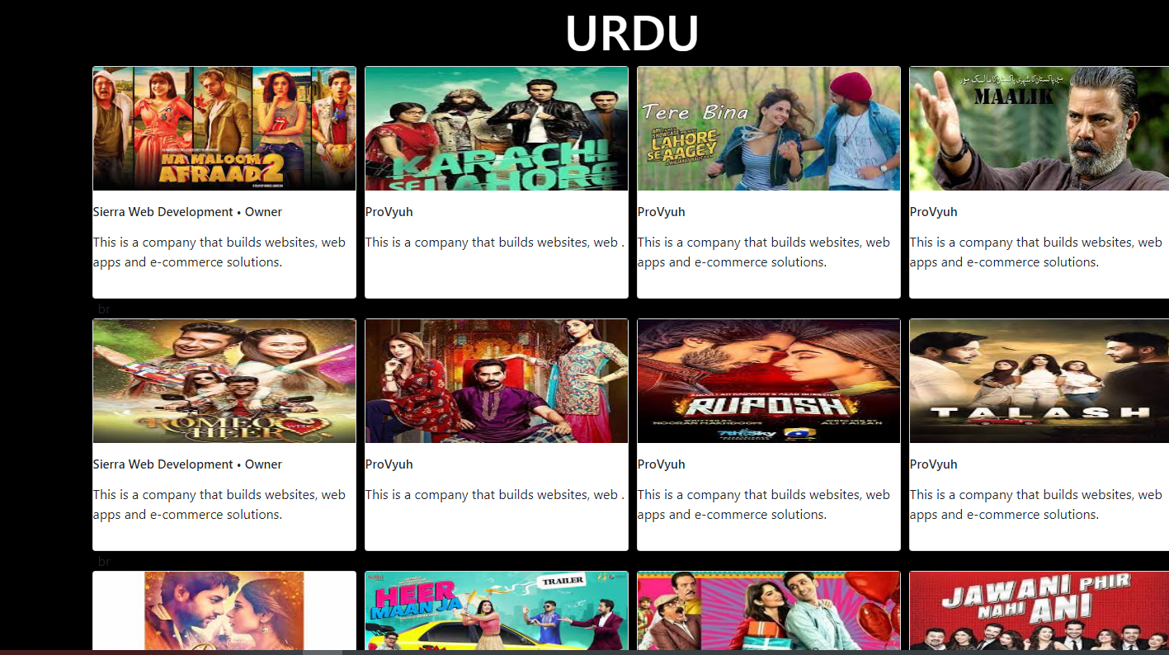

***Code of Urdu shows page***

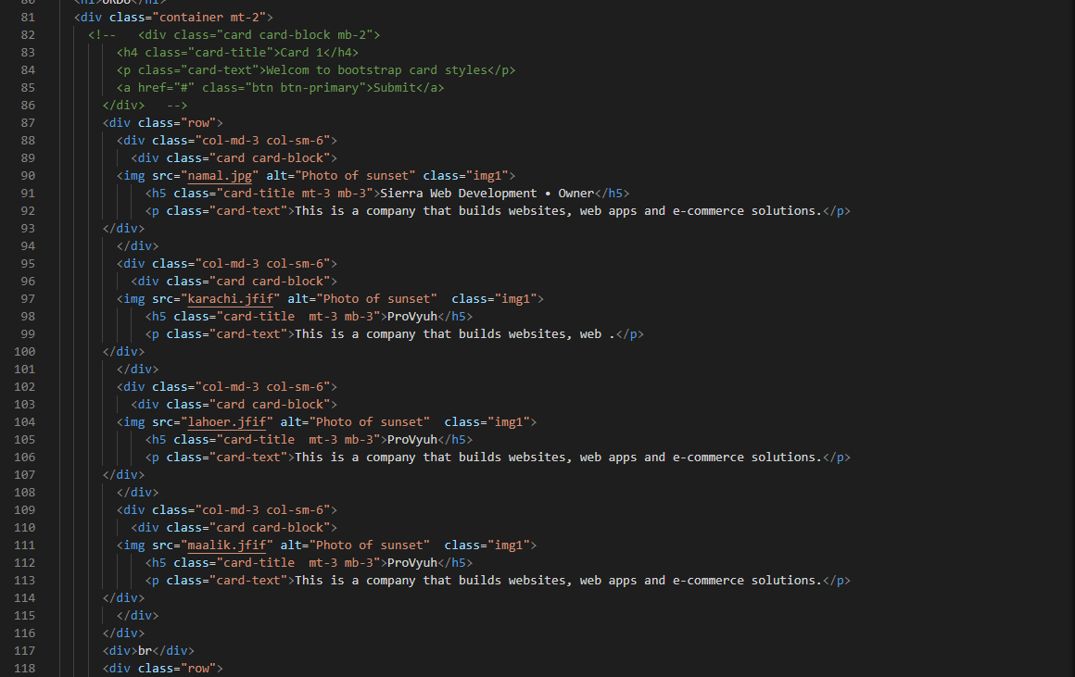

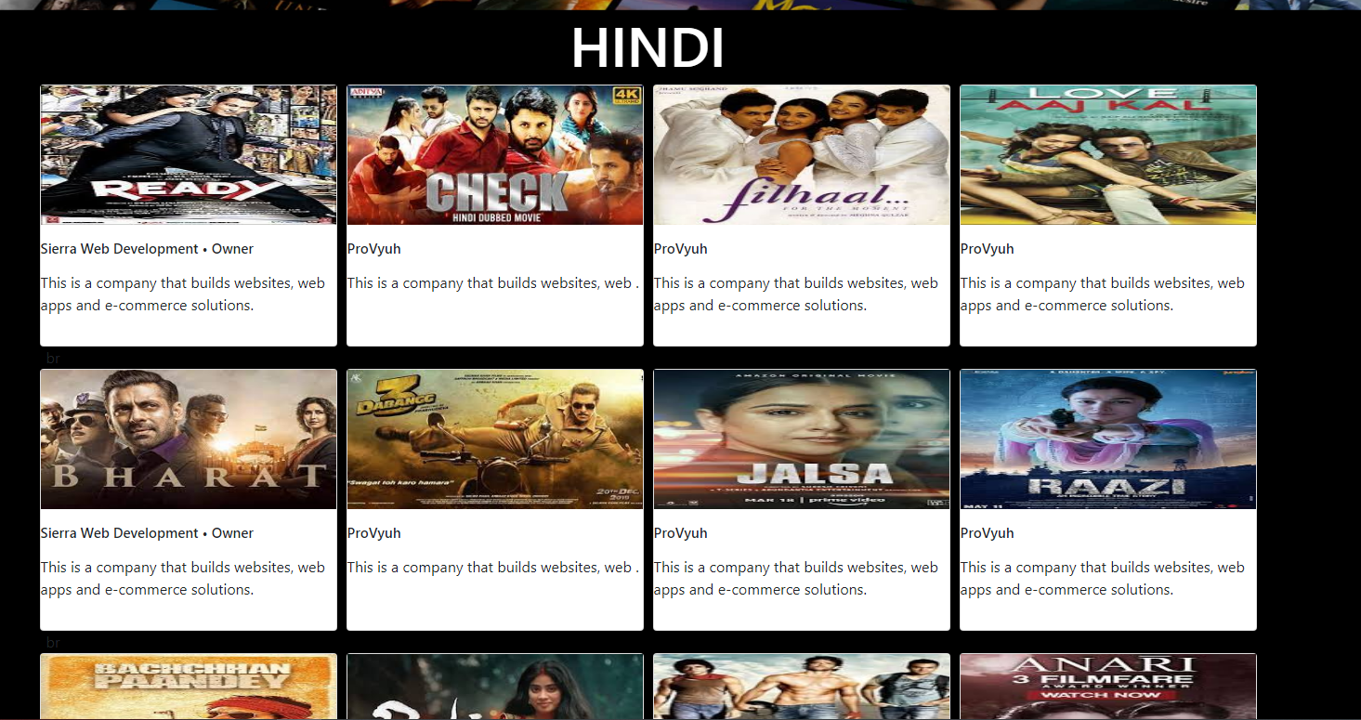

***Code of Hindi shows page***

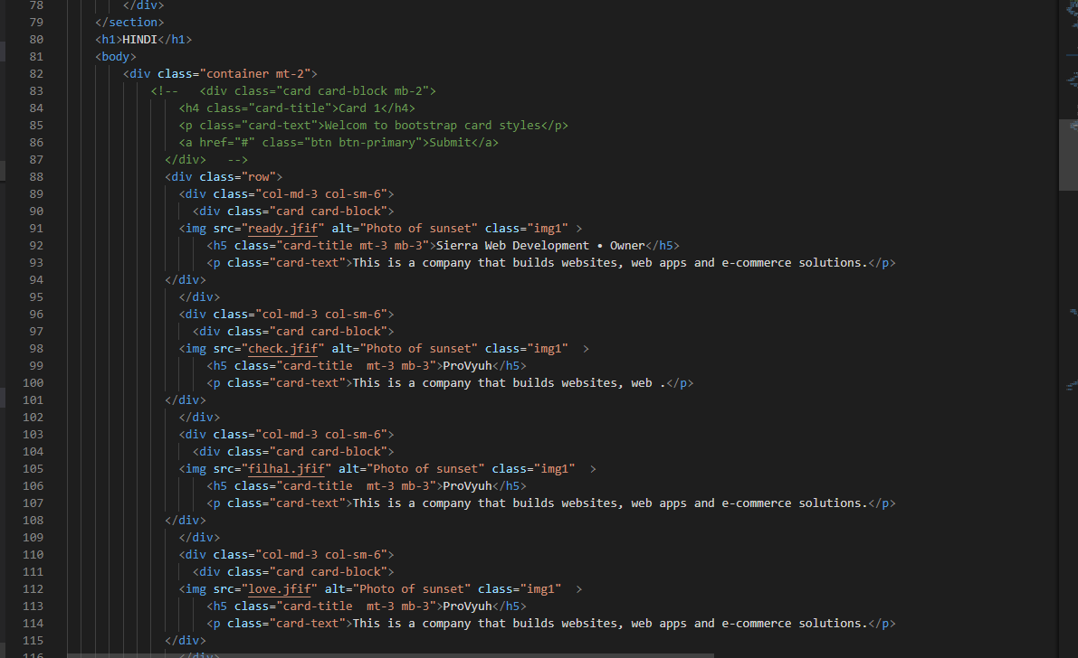

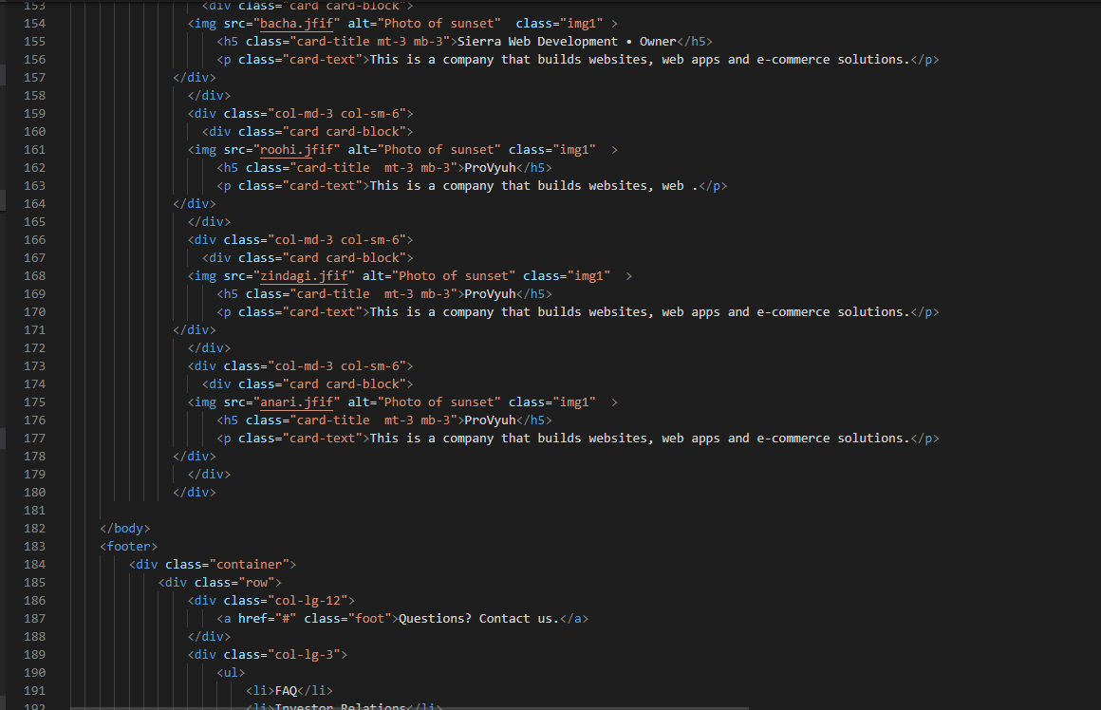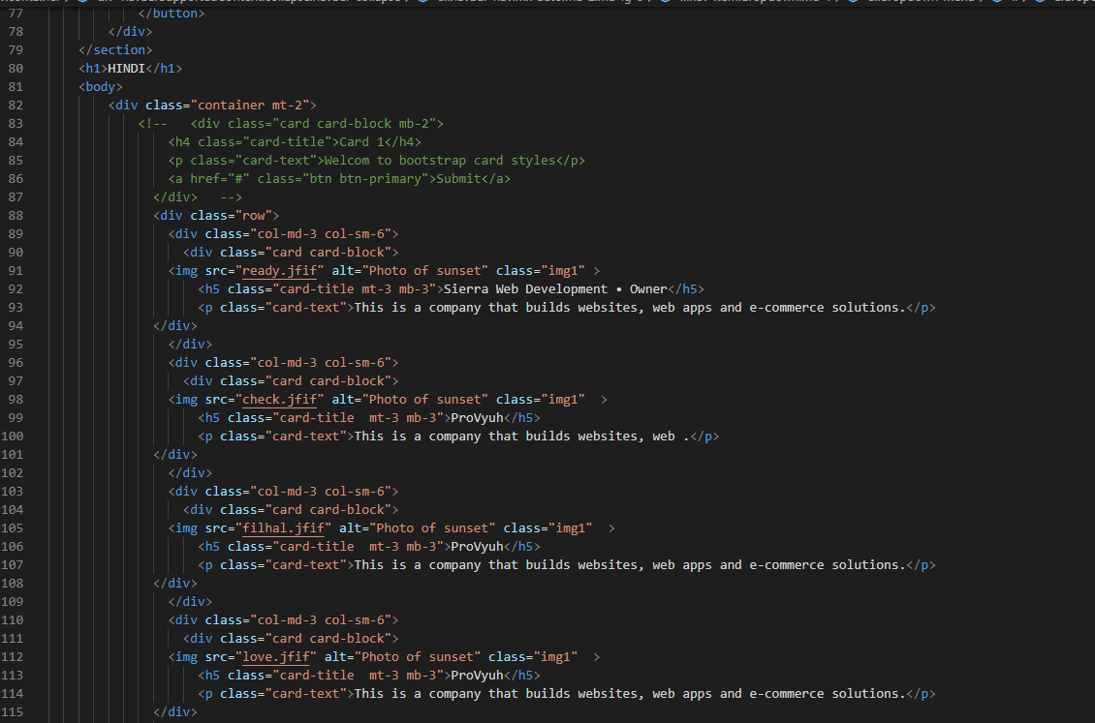

***Code of Contact Form***

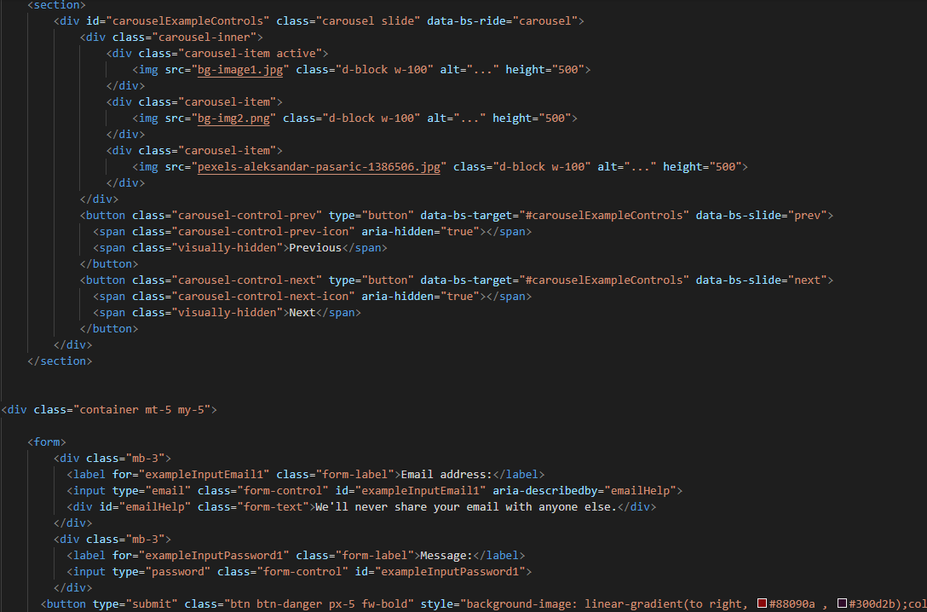

 *Contact Form:*

*In contact forms customer have to give details:*

*Your Full Name: Customer have to write their full name.*

*Your Email: Email won't be accepted without @ we have given validations.*

*Description: Description is optional but if they want to mention any validation or request about something of our theater they can write there*.

1. ***Questions About Theater (index (1).html):***



***Figure 12: Questions about theater***

If any client has any query about our theater shows or our theater so they can have solutions over here

***Inner Page(inner.html):***

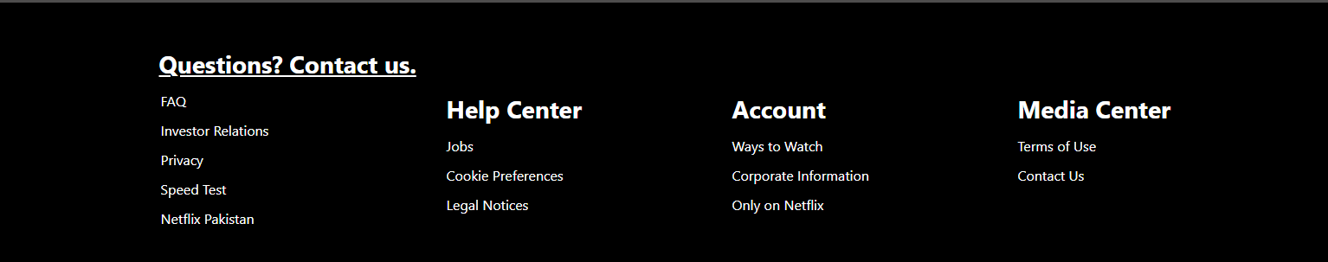

***Figure 14: Footer***

We have given some animations in footer to make our website more relaxing.

***Code of Footer***



